Given a binary tree, find the lowest common ancestor (LCA) of two given nodes in the tree.

According to the [definition of LCA on Wikipedia](https://en.wikipedia.org/wiki/Lowest_common_ancestor): “The lowest common ancestor is defined between two nodes p and q as the lowest node in T that has both p and q as descendants (where we allow **a node to be a descendant of itself**).”

Given the following binary tree:  root = [3,5,1,6,2,0,8,null,null,7,4]

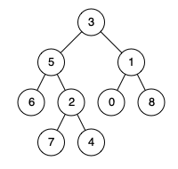

**Example 1:**

**Input:** root = [3,5,1,6,2,0,8,null,null,7,4], p = 5, q = 1

**Output:** 3

**Explanation:** The LCA of nodes 5 and 1 is 3.

**Example 2:**

**Input:** root = [3,5,1,6,2,0,8,null,null,7,4], p = 5, q = 4

**Output:** 5

**Explanation:** The LCA of nodes 5 and 4 is 5, since a node can be a descendant of itself according to the LCA definition.

**Note:**

* All of the nodes' values will be unique.
* p and q are different and both values will exist in the binary tree.